AGURCHAND MANMULL JAIN COLLEGE
(A unit of Sri S.S.Jain Educational Society)
Meenambakkam, Chennai – 600114
CO-EDUCATION
A Jain Minority Institution Affiliated to the University of Madras
NAAC Reaccredited
REPORT ON
WOMEN DEVOLOPMENT CELL INAGURATION
The Women Devolopment Cell - ENLIVEN was inaugurated on 10/08/2019 by Ms Mahalakshmi Saravanan,.Founder of WEI - Women Entrepreneurs India LTD and TEDx motivational Speaker. The Office Bearer's are:
Dr. M.S.Sasilekha Sunil, Advisor & Convener
MEMBERS
Dr B.Jayanthi
Dr. M. Thamarai Selvi
Dr. M. K. Kalpana
Ms. Sangeetha Rajappa - Chief Manager
Ms. N. Durga Devi- Deputy Warden
Ms. Abinaya Muralidharan - Counsellor
Dr. Nandhini Devi - College Doctor
The main objective of this Cell is to make the lady staff and girl Students feel safe and sound in and around the College campus.

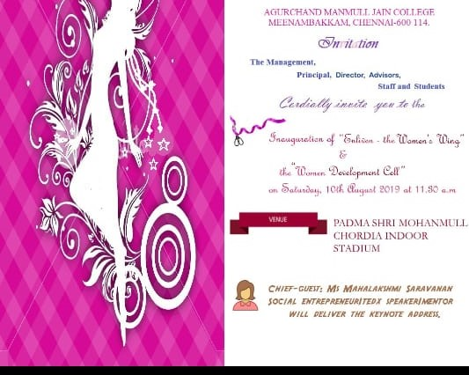
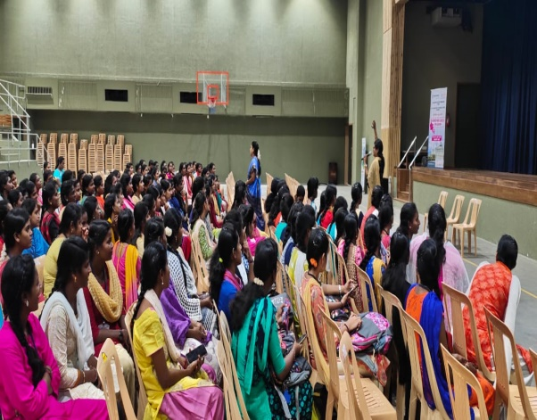
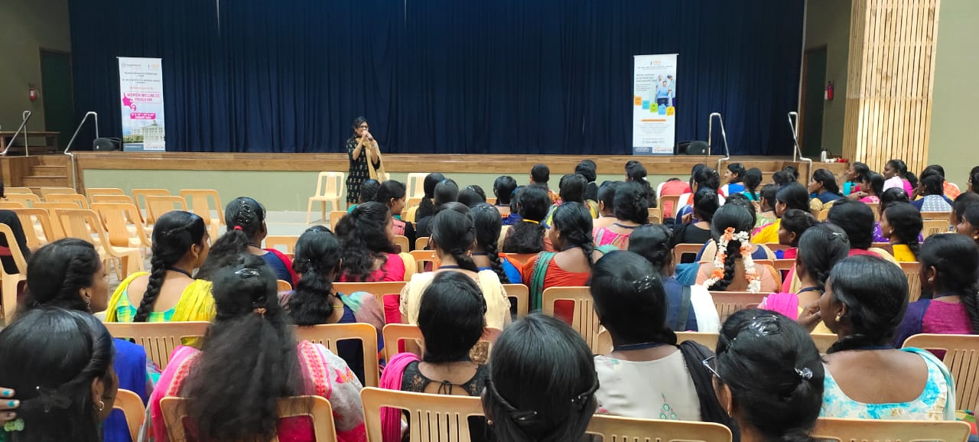
WDC organized many resourceful Programs
1. SMART GIRL TRAINING PROGRAM for all the First Year Girls Aug. 7th &8th, 24th &25th Sept 2019 and 24th & 25th Feb. 2020.
2. Arts and Crafts Workshop on 20th Sept. 2019 by Ms. Jayashree Narayanan, Fevicryl Specialist.
3. EMPOWER - a self- defense program for girls on 6th Dec 2019 by NGO. ALERT
4. Four days ( 9th, 10th, 23rd,24th Jan2020) HEALTH AND WELL NESS CAMP for all Women on campus in association with Rajasthani Medical Foundation and Dr Rela Institute and Medical Center.
5. All girls of Shift ll clad in Yellow Colour Sarees and accompanied by the lady faculty members participated in the Mass Singing program BHARATHEEYA SAMSKARA GANAM Organized by IMCTF ( Initiative for Moral and Cultural Foundation) on our College grounds on 24th Jan. 2020 and all received Certificates.The Chief Guest for the occasion was Playback singer Ms. Sujatha Mohan.
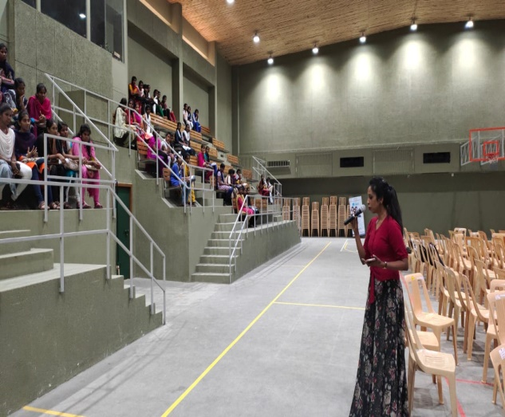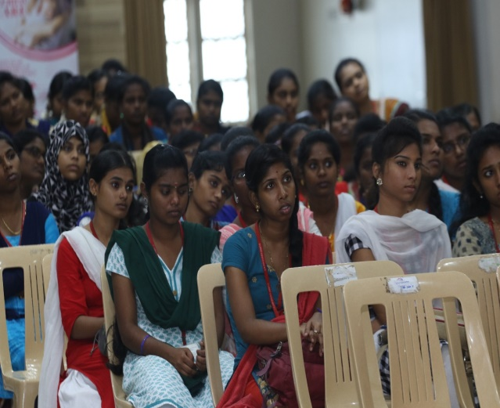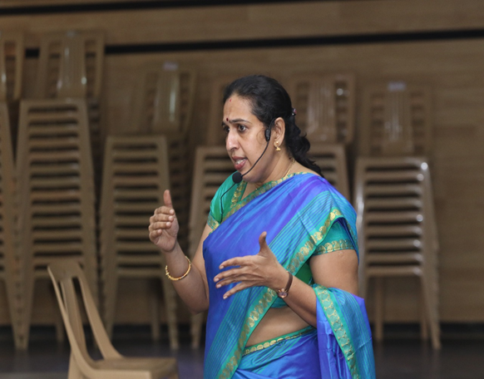
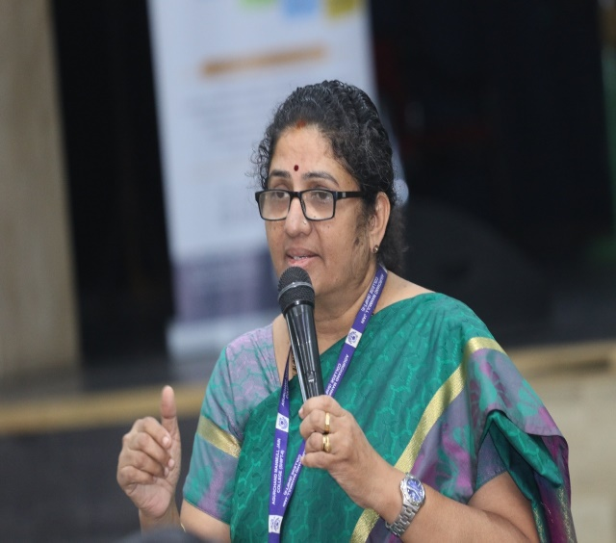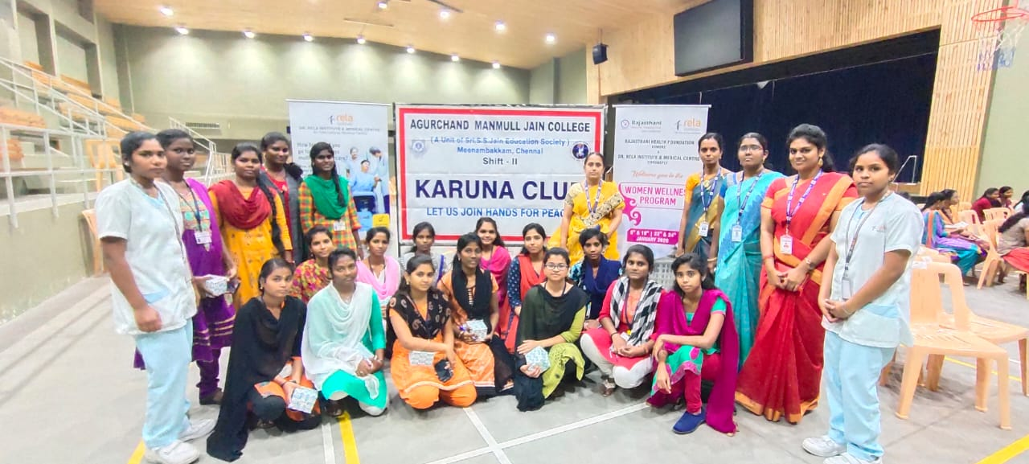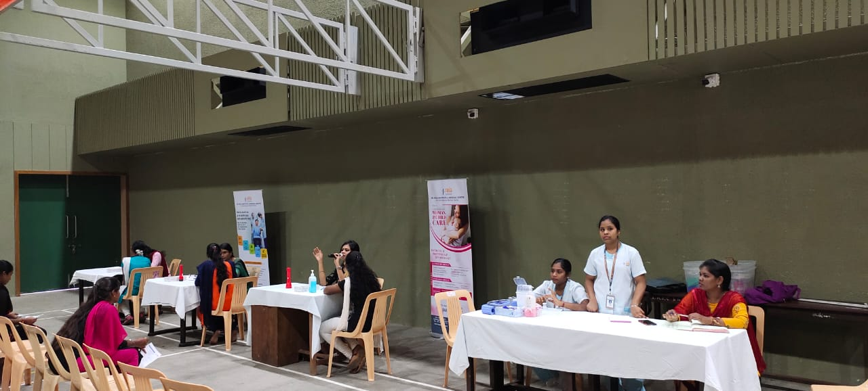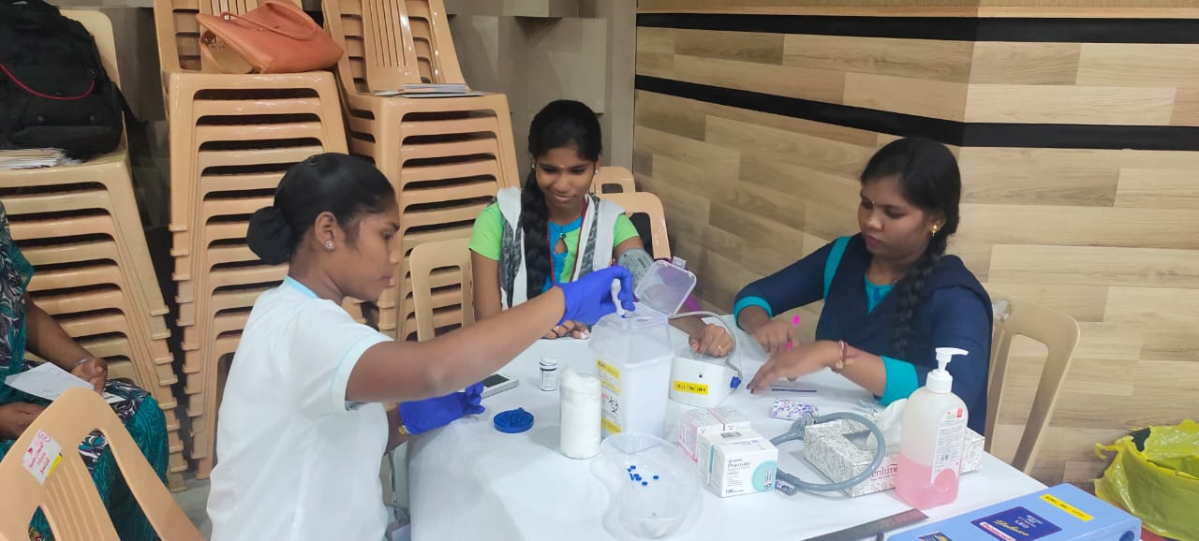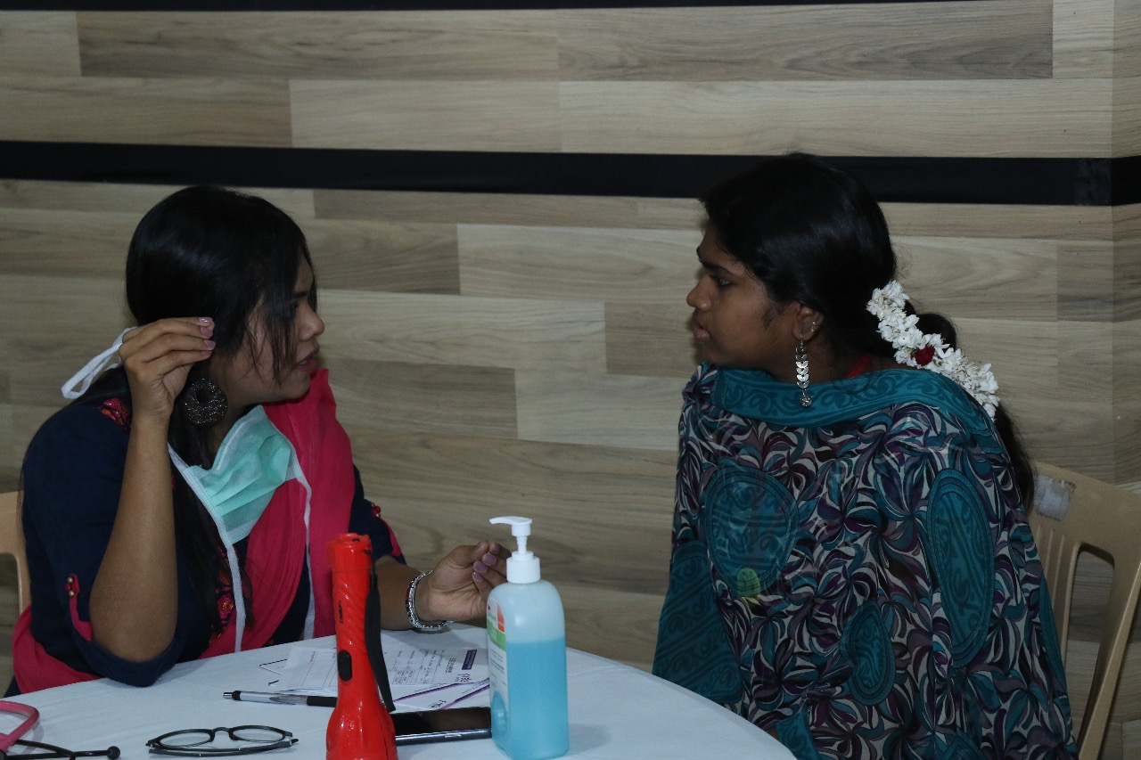

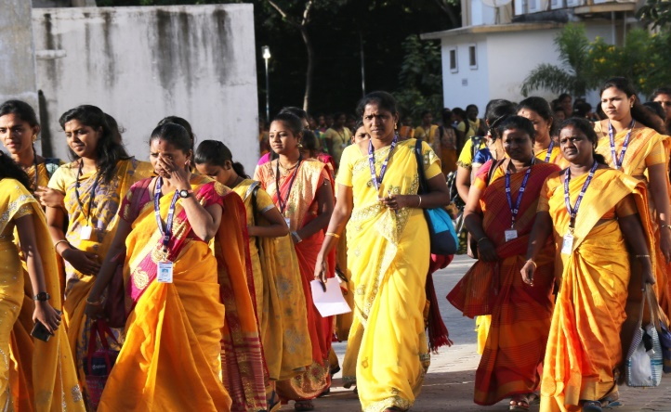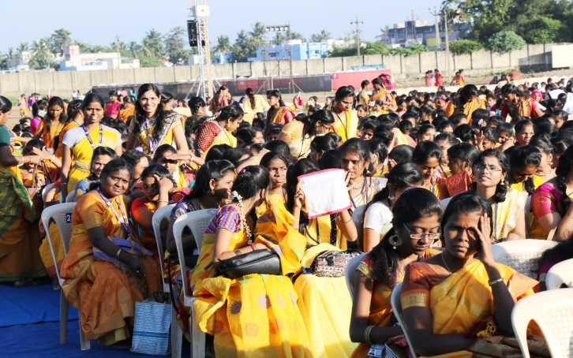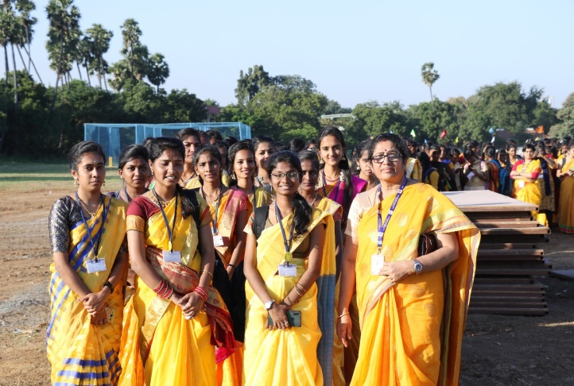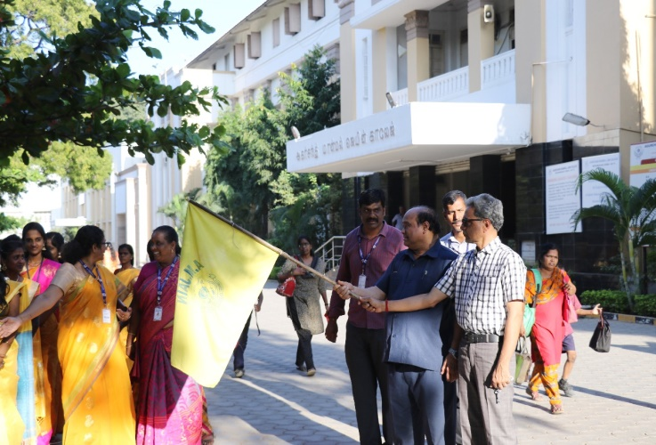
The International Women's Day 2019 -2020
" An Equal World is an Enabled World" was celebrated on Campus on 6th March .Dr. Mrs. A.Nirmala, Former Principal & Secretary of Ethiraj College for Women was the Chief - Guest for the celebrations of Shift l and Ms Usha Ramky, Life Skill Catalyst and Founder of Global Adjustments Foundation was the Chief Guest of Shift ll celebrations.
